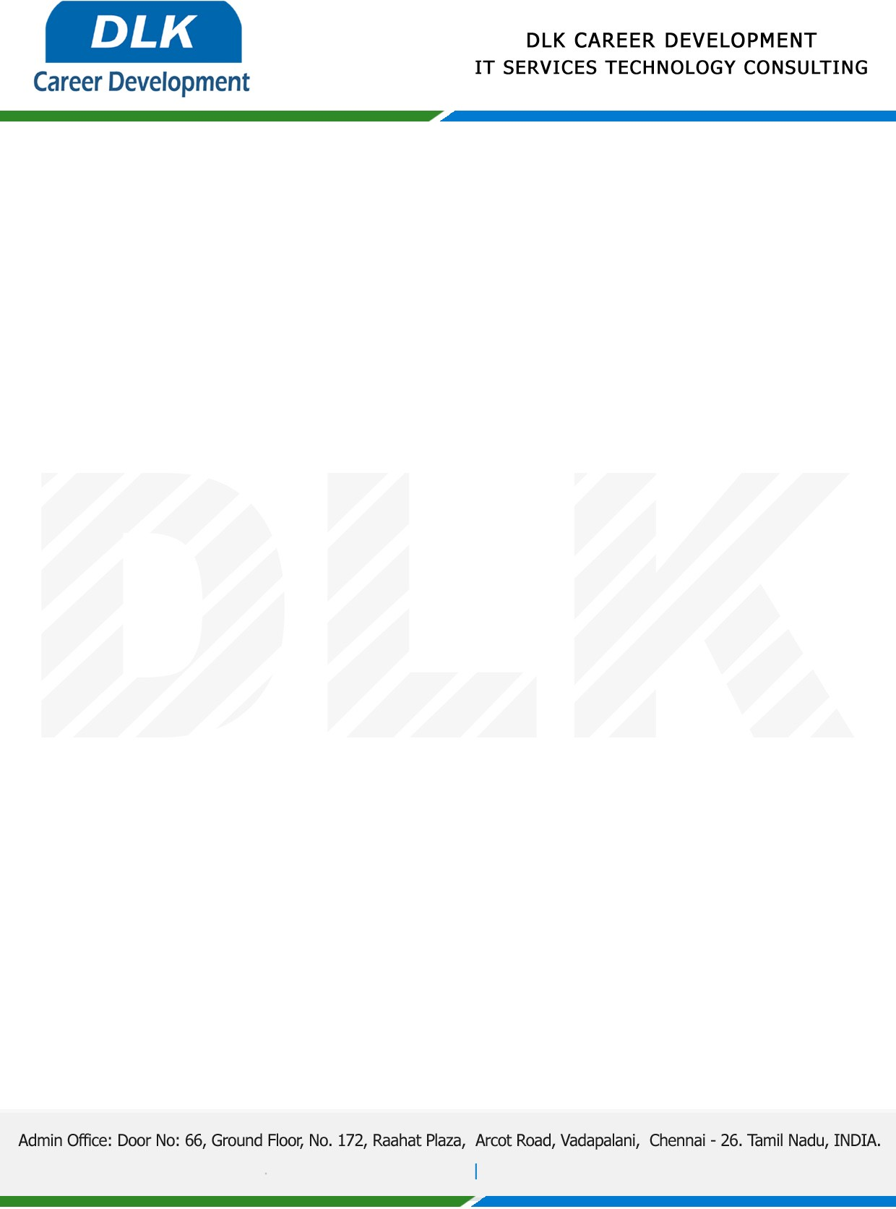

**Date: 02/ March /2023**

**SUB: PROJECT COMPLETION CERTIFICATE**

This is to certify that **MR RATHINAKUMAR S (REG NO:** **212000090) BCA- Computer Application,** final year student **SIVET College, Chennai** has Successfully Completed the Project Work under the domain of “**Java”** in our organization during the Period **(01st December 2023** to **28th February 2023).**

**Topic:** A Expired Medicine Waste Collector Website and Application**.**

We appreciate your interest in **DLK CAREER DEVELOPMENT**

**“Best Wishes for Your Future Endeavors “**

